**PRACTICAL NO.2**

**Apply the what – if Analysis for data visualization. Design and generate necessary reports**

**based on the data warehouse data. Use Excel.**

**1.**

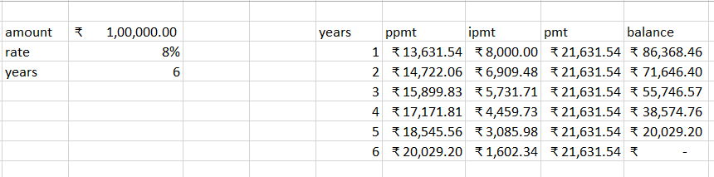

**2.**Your planning a road trip from mumbai to goa you have estimated the distance 600km,your cars average mileage 15km/ltr and the current petrol price is 110per/ltr.You want analyse how changes in petrol prices might affect the total fuel cost for the trip.

